**Part One:**

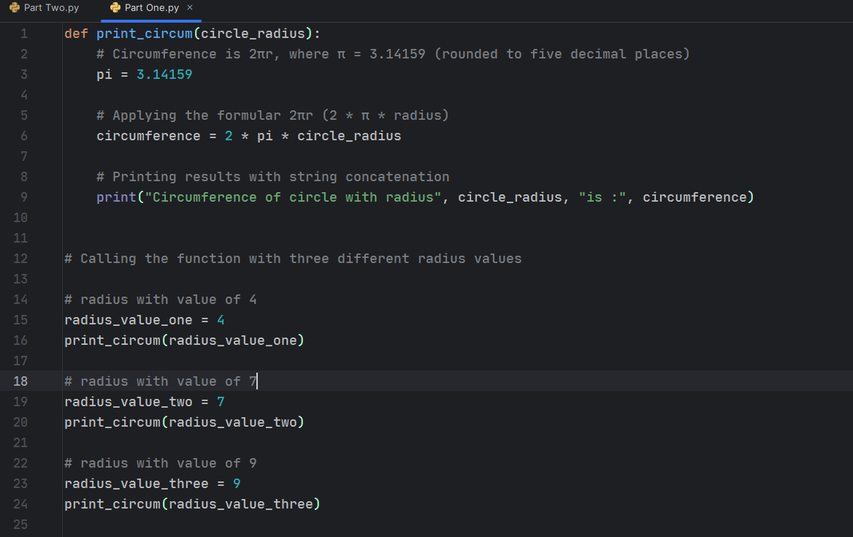

Results:

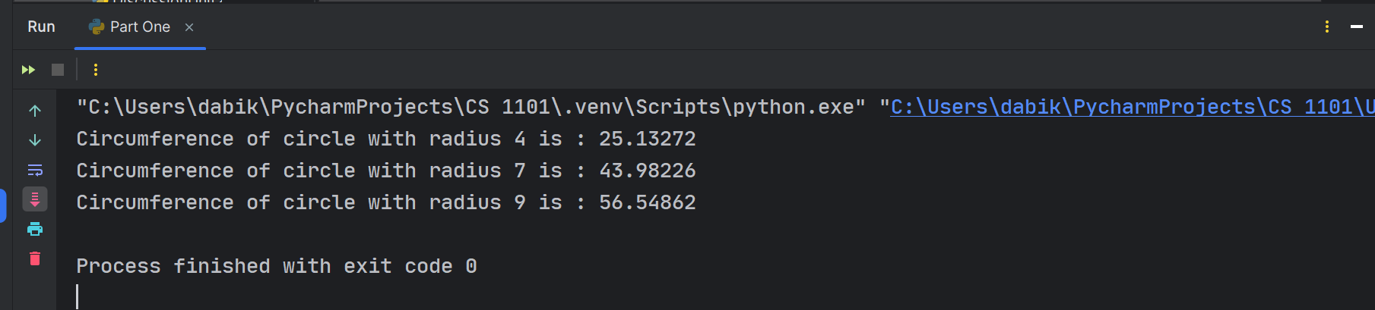

Explanation:

* Python function that calculates a circle’s circumference.
* It is calculated by 2πr, where π = 3.14159 (rounded to five decimal places)
* Static circle radius variables are defined and called (printing results)
* Results printed by the Pythin interpreter as seen above.

**Part Two:**

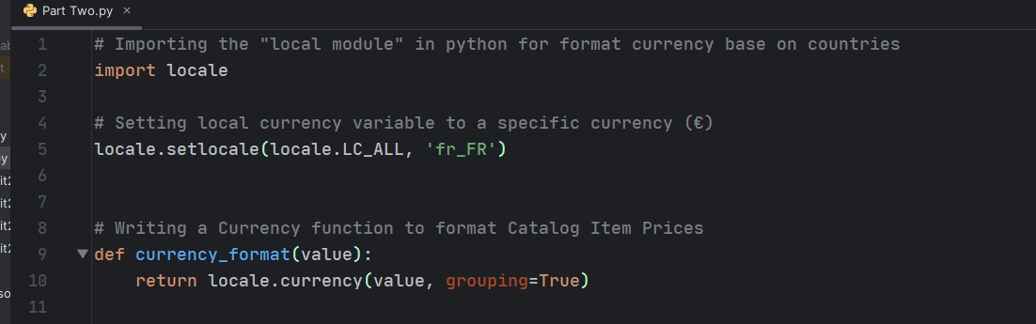

Explanation

* Imported the “locale module” from Python to format currency values after calculating discounts after purchases.
* I use the “fr_FR” symbol to set the local currency to EURO (€)
* Wrote a currency function for dynamic calls in my code. This will help update the currency format anywhere in my code in case I decide to change my currency.
* Setting “grouping=True” make sure the amount is displayed in thousands (1 000.00 €)

Note:

To get the list of supported currencies;

* In Windows (after importing the locale module)
  + Print lang in locale.windows_locale.values():

print(lang)

* In other operating systems
  + Print lang in locale.locale_alias.values():

print(lang)

(Pimeh, n.d.)

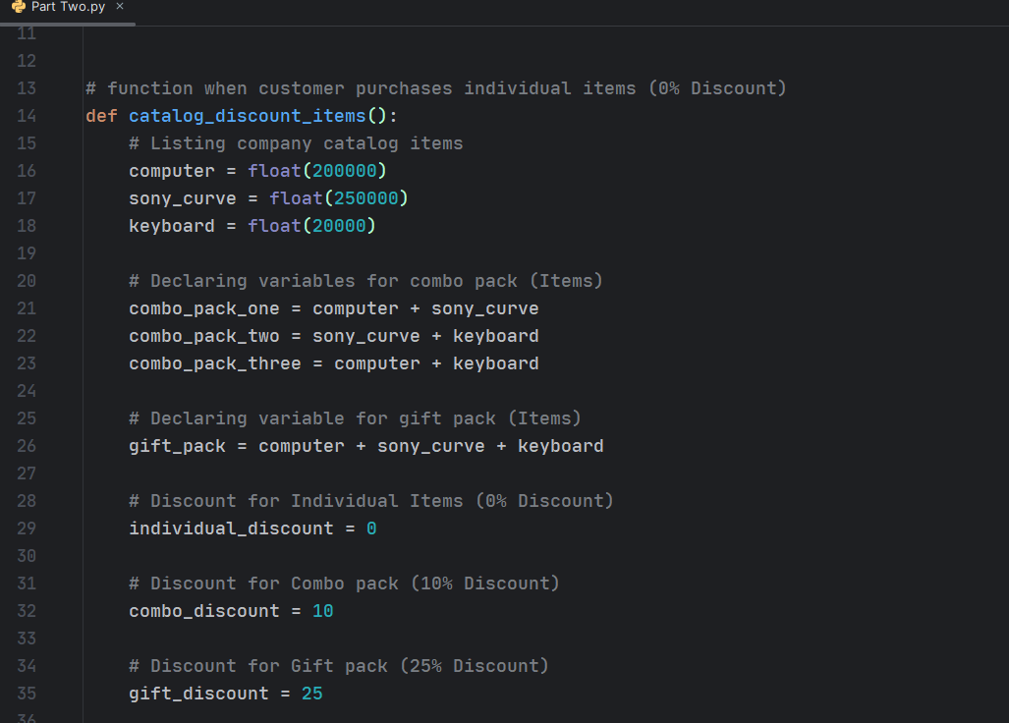

Explanation

* Defined the *catalog_discount_items function*
* Declaring variables with *float type* since percentage calculation will be involved.
* Listing individual items*, combo items* and *gist items* for easy calculations
* Setting variables for each percentage discount for dynamic use my my code

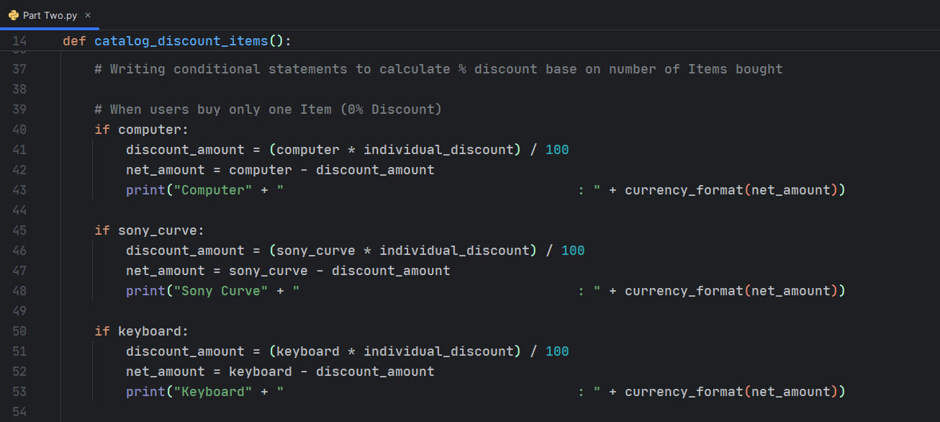

Explanation

* Computing discount for single items purchased by users
* Calling the discount variable for single items
* Calling the currency format function to format the net amount the customer has to pay.
* Concatenating the net amount with the purchased Item in string.
* Using conditional statement to display results if one item is purchased

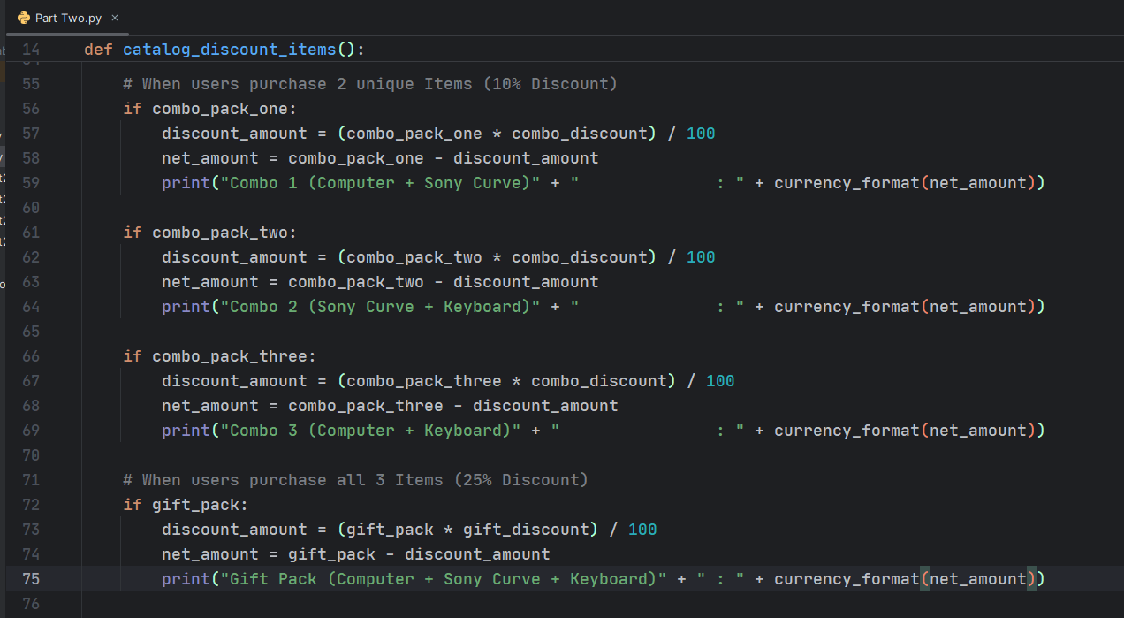

Explanation

* Computing discount for 3 items and 3 items purchased by users
* Calling the discount variable for combo and gift items
* Calling the currency format function to format the net amount the customer has to pay.
* Concatenating the net amount with the purchased Item in string.
* Using conditional statement to display results if 2 or all three items are purchased

(Allen Downey, 2015)

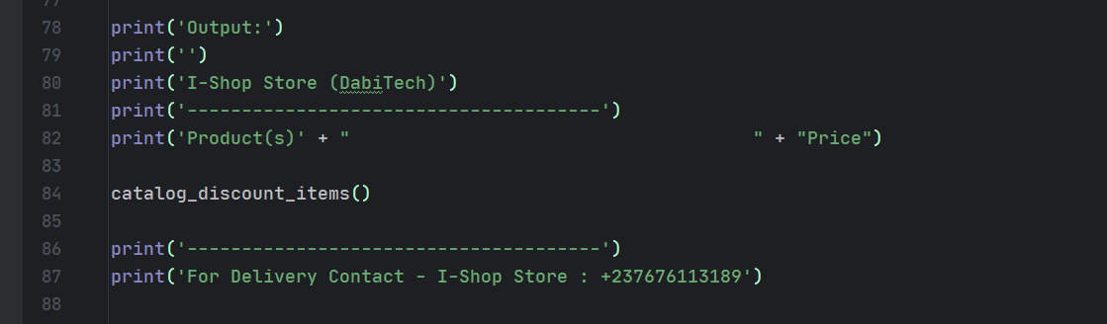

Explanation

* Formating results to display in a tabular form for easy ready by users
* Calling the *catalog_discount_items* function to print all function body statements

Results:

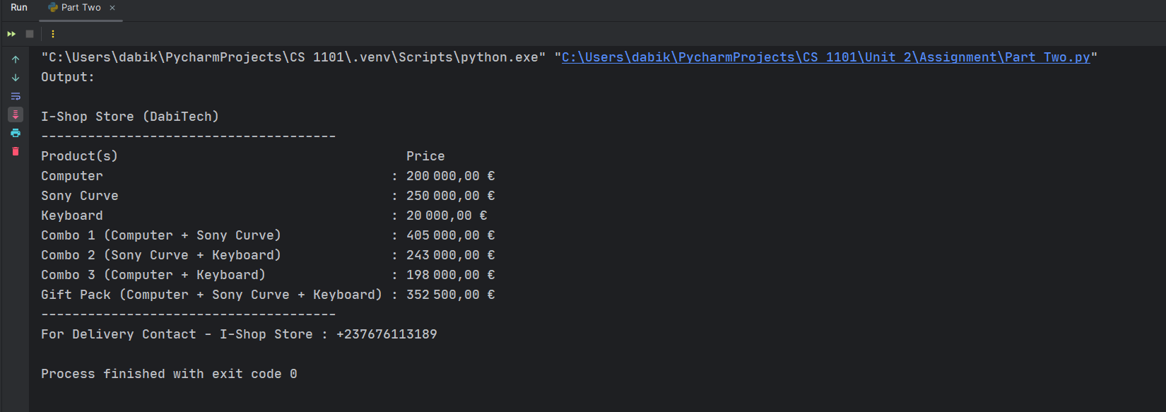

* Output/results displayed with the desired currency included

# References

Allen Downey, G. T. (2015). *Think Python: How to Think Like a Computer Scientist.* Needham, Massachusetts: Green Tea Press.

Pimeh, D. (n.d.). *How to Format Number as Currency String in Python*. Retrieved from How to Format Number as Currency String in Python: https://stackabuse.com/format-number-as-currency-string-in-python/